EXPERIMENT 7 V.DEVI PRIYA 192512337
import numpy as np
import pandas as pd
import matplotlib.pyplot as plt
import time

# EXPERIMENT 7
# Edge-Based Feature Extraction and Bandwidth Reduction

print("=" * 55)
print("IoE SENSOR DATA OPTIMIZATION")
print("=" * 55)

# STEP 1: Generate sensor data
np.random.seed(42)

n = 1000

temperature = np.random.normal(30, 5, n)
humidity = np.random.normal(60, 10, n)
pressure = np.random.normal(1013, 5, n)

raw_data = pd.DataFrame({
"Temperature": temperature,
"Humidity": humidity,
"Pressure": pressure
})

print("\n1. RAW SENSOR DATA")
print(raw_data.head())
print("Total sensor readings:", len(raw_data))

# STEP 2: Calculate raw data size
raw_size = raw_data.memory_usage(deep=True).sum()

# STEP 3: Edge-based feature extraction
start_time = time.perf_counter()

processed_data = pd.DataFrame({
"Average_Temperature": raw_data["Temperature"].rolling(
window=10, min_periods=1
).mean(),
"Average_Humidity": raw_data["Humidity"].rolling(
window=10, min_periods=1
).mean(),
"Average_Pressure": raw_data["Pressure"].rolling(
window=10, min_periods=1
).mean()
})

# Keep one feature row for every 10 sensor readings
features = processed_data.iloc[9::10].reset_index(drop=True)

processing_time = time.perf_counter() - start_time

print("\n2. EDGE FEATURE EXTRACTION")
print(features.head())
print("Raw rows:", len(raw_data))
print("Processed feature rows:", len(features))

# STEP 4: Calculate processed data size
processed_size = features.memory_usage(deep=True).sum()

# STEP 5: Calculate bandwidth reduction
reduction = (1 - processed_size / raw_size) * 100

print("\n3. BANDWIDTH REDUCTION")
print("Raw data size:", raw_size, "bytes")
print("Processed data size:", processed_size, "bytes")
print("Data size reduction:", round(reduction, 2), "%")

# STEP 6: Simulate transmission latency
data_rate = 100000 # bytes per second

raw_latency = raw_size / data_rate
processed_latency = processed_size / data_rate

print("\n4. TRANSMISSION LATENCY")
print("Raw data latency:", round(raw_latency, 4), "seconds")
print("Processed data latency:", round(processed_latency, 4), "seconds")
print("Feature processing time:", round(processing_time, 6), "seconds")

# STEP 7: Plot data size comparison
plt.figure(figsize=(7, 4))
plt.bar(
["Raw Data", "Processed Data"],
[raw_size, processed_size]
)
plt.title("Raw vs Processed Data Size")
plt.ylabel("Memory Size (bytes)")
plt.tight_layout()
plt.show()

# STEP 8: Plot sensor readings and extracted features
plt.figure(figsize=(9, 4))
plt.plot(
raw_data["Temperature"].iloc[:100].to_numpy(),
label="Raw Temperature"
)
plt.plot(
processed_data["Average_Temperature"].iloc[:100].to_numpy(),
label="Edge Feature"
)
plt.title("Raw Sensor Data vs Edge-Extracted Feature")
plt.xlabel("Sample Number")
plt.ylabel("Temperature")
plt.legend()
plt.tight_layout()
plt.show()

# STEP 9: Plot latency comparison
plt.figure(figsize=(7, 4))
plt.bar(
["Raw Data", "Processed Data"],
[raw_latency, processed_latency]
)
plt.title("Transmission Latency Comparison")
plt.ylabel("Estimated Latency (seconds)")
plt.tight_layout()
plt.show()

# STEP 10: Save results
raw_data.to_csv("experiment7_raw_data.csv", index=False)
features.to_csv("experiment7_processed_features.csv", index=False)

print("\nFINAL RESULT")
print("Edge-based feature extraction completed.")
print("Raw and processed data compared successfully.")
print("Bandwidth reduction and latency calculated.")
print("CSV files saved successfully.")

=======================================================
IoE SENSOR DATA OPTIMIZATION
=======================================================

1. RAW SENSOR DATA

Temperature Humidity Pressure
0 32.483571 73.993554 1009.624109
1 29.308678 69.246337 1012.277407
2 33.238443 60.596304 1009.037900
3 37.615149 53.530632 1011.460192
4 28.829233 66.982233 1003.531927
Total sensor readings: 1000

2. EDGE FEATURE EXTRACTION
Average_Temperature Average_Humidity Average_Pressure
0 32.240306 64.873074 1011.590267
1 26.046709 63.803456 1009.842051
2 28.890782 63.979678 1013.155483
3 28.449467 58.792668 1014.362038
4 28.735889 64.908811 1012.320542
Raw rows: 1000
Processed feature rows: 100
3. BANDWIDTH REDUCTION
Raw data size: 24132 bytes
Processed data size: 2532 bytes
Data size reduction: 89.51 %

4. TRANSMISSION LATENCY
Raw data latency: 0.2413 seconds
Processed data latency: 0.0253 seconds
Feature processing time: 0.003774 seconds
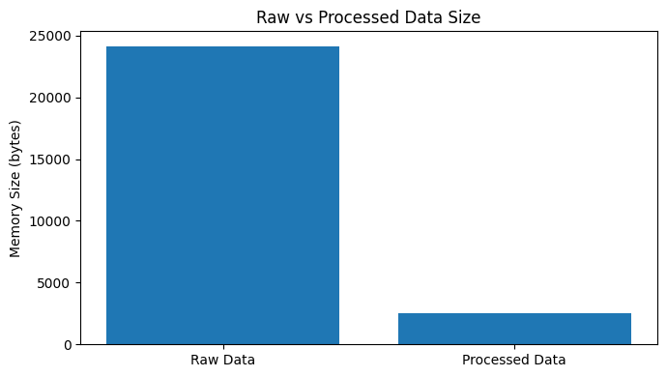
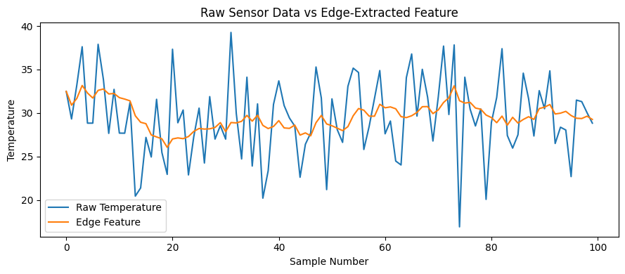
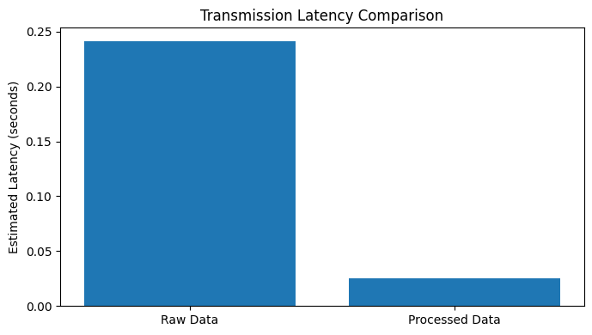
FINAL RESULT
Edge-based feature extraction completed.
Raw and processed data compared successfully.
Bandwidth reduction and latency calculated.
CSV files saved successfully.

